**DEPARTMENT OF HARBOUR AND OCEAN ENGINEERING**

**QUESTION BANK**

**COURSE: STRENGTH OF MATERIAL (HE306) YEAR/SEM: 2ND /III**

**UNIT-I-SIMPLE STRESS AND STRAIN**

**PART-A**

**EACH QUESTION CARRIES 2 MARKS**

1. What is stress?
2. Define Hook’s Law.
3. Define Factor of safety.
4. List out the parameters for material selection.
5. List out the main classification of types of engineering materials.
6. What is Composite material and give an example.
7. What is strength of material?
8. What is a one Newton force?
9. Define Modulus of Rigidity (N).
10. Define longitudinal strain and lateral strain.

**PART-B**

**EACH QUESTION CARRIES 4 MARKS**

1. Define the loads and the classification of loads? What is mean by modulus of elasticity?
2. A steel bar of rectangular cross-section 4cmx3cm, carries an axial loads of 50KN. Estimate the average tensile stress over a normal cross section of the bar.
3. A steel bolt , 5.50cm in diameter , carries a tensile load of 40KN. Estimate the average tensile stress at the section ‘a’ and at the screwed section ‘b’ where the diameter at the root of the thread is 4.50cm. draw with diagram
4. Define the term: Stress& strain B. Longitudinal strain & Lateral strain C. Hook’s Law D. Poisson’s ratio.
5. Define the term Mohr’s circle? Draw the neat sketch?
6. 8. A tensile stress at a point across two material. Perpendicular plan and 120 N/mm2 and 60 N/mm2 determine the normal tangential and resultant stresses on a plane inclined at 30°c to the axis of stress
7. Discuss about Elasticity and Elastic limit of a body.
8. Find the Young Modulus of a brass Rod of diameter 25 mm and of length 250 mm which is subjected to a tensile load of 50 KN. When the extension of the rod is equal to 0.3 mm.
9. A rod 150 cm long and of diameter 2.0 cm is subjected to an axial pull of 20 KN. If the modulus of elasticity of the material of the rod is 2x105 N/mm2. Determine (i) Strain and Percentage of elongation of the rod.
10. What is strain? And list out the different types of strain.
11. Discuss about the Ductility of a material and how it is measured?
12. Discuss about failure point or Breaking stress.
13. Analysis of Bars of varying section with a neat sketch?

**PART-C**

**EACH QUESTION CARRIES 14 MARKS**

* 1. An axial pull of 35000n is acting on a bar consisting of tree length. If the young’s modulus =2x105 N/mm2, determine: 1. Stress in each section 2.Total extension of the bar.
  2. Explain in detail about principal strain and principle stress with neat sketch? And also explain the relationship between stress and strain?
  3. Find the young’s modulus of a bars a rod of diameter 25 mm and of length 250mm which is subjected to a tensile load of 50 KN when the extension of the rod is equal to 0.3 mm.
  4. A rod 150cm long and of diameter 2.0cm is subjected to an axial pull of 20 KN. if the modulus of elasticity of the material of the rod is2x105 N/mm2 determine stress , strain and elongation of the rod.
  5. Define the term Mohr’s circle with neat sketch and also explain the different case for graphical method.
  6. Find the young’s modulus of a bars a rod of diameter 25 mm and of length 250mm which is subjected to a tensile load of 50 KN when the extension of the rod is equal to 0.3 mm. And if the modulus of elasticity of the material of the rod is2x105 N/mm2 determine stress, strain and elongation of the rod.
  7. The ultimate stress for a hollow steel column which carries an axial load of 1.9 MN is 480 N/mm2. If the external diameter of the column is 200 mm, determine the internal diameter of the column. Take the factor of safety as 4.

8. An axial pull of 35000 N is acting on a bar consisting of three lengths as shown in Figure. If the Young’s Modules E = 2.1 x 10 5 N/mm2. Deter mine

1. The stress in each section.
2. Total extension of the Bar

9. A steel rod of 3 cm diameter is enclosed centrally in a hollow copper tube of external diameter 5 cm and internal diameter of 4 cm. The composite bar is then subjected to an axial pull of 45000N. If the length of each bar is equal to 15 cm. Determine

(i) The stress in the rod and tube

(ii) Load carried by each bar

10. A brass bar, having cross-sectional area of 1000 mm2, is subjected to axial forces as shown in Figure (B). Find the total elongation of the bar. Take E=1.05 x 105 N/mm2.

**UNIT-II-ANALYSIS OF FRAME AND PRESSURE VESSEL**

**PART-A**

**EACH QUESTION CARRIES 2 MARKS**

1. List the types of Frames.
2. Explain the reaction and supports of the frame.
3. What is Imperfect frame?
4. Define perfect frame?
5. What is frame?
6. What is Cantilever truss?
7. What is the condition for deficient frame?
8. What is hinged support and roller support?
9. Define thin cylinders.
10. List out examples for the pressure vessels.
11. What is maximum shear stress in thin cylinders?
12. What is Hoop stress?

**PART-B**

**EACH QUESTION CARRIES 4 MARKS**

1. Define the term frame and the types?
2. Give the assumption made in finding out the forces in a frame? And also explain the reaction and supports of the frame?
3. Explain the deformation of thin cylinders and shells?
4. What the different methods of joins with adiagram?
5. Discuss about the analysis of frame**.**
6. A Cylinder of internal diameter 2.5 m and of thickness 5 cm contains a gas. If the tensile stress in the material is not to exceed 80 N/mm2, determine the internal pressure of gas.
7. A cylindrical pipe of diameter 1.5m and the thickness 1.5 cm is subjected to internal fluid pressure of 1.2 N/mm2. Determine:

(i). Longitudinal stress developed in the pipe, and

(ii). Circumferential stress developed in the pipe.

8. The stresses at a point 200N/mm2 (tensile stress) 100N/mm2 (compression). Determinethe resultant stress in magnitude and direction or a plane inclined at 60°c to major axis.

* 1. A Cylinder of internal diameter 5.0 m and of thickness 7 cm contains a gas. If the tensile stress in the material is not to exceed 60 N/mm2, determine the internal pressure of gas.

10. A Cylinder of internal diameter 7.5 m and of thickness 15 cm contains a gas. If the tensile stress in the material is not to exceed 280 N/mm2, determine the internal pressure of gas.

**PART-C**

**EACH QUESTION CARRIES 14 MARKS**

1. Explain in detail about the Analysis of bars of varying sections with a neat sketch.
2. A truss of 7.5 m span is loaded as shown in **Figure (A)**. Determine the forces in the members using method of joints.

**30O**

**60O**

**A**

**D**

**C**

**1 KN**

**7.5 m**

1. A truss of span 5 m is loaded as shown in **Figure (1).** Find the reactions and force in all the members of the truss using the method of sections.

**30O**

**60O**

**A**

**D**

**C**

**1 KN**

**5 m**

**B**

**2 KN**

4. A truss of 8 m span is loaded as shown in **Figure (A)**. Determine the forces in the members using method of joints.

**60O**

**30O**

**A**

**D**

**C**

**1 KN**

**8 m**

**5 KN**

**B**

5. Determine the forces in all the members of cantilever truss as shown in Figure (A).

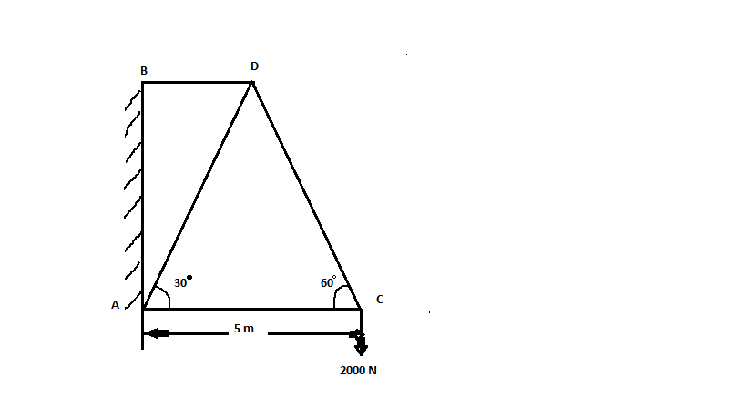

6. A truss of 17.5 m span is loaded as shown in **Figure (A)**. Determine the forces in the members using method of section.

**30O**

**60O**

**A**

**D**

**C**

**15 KN**

**17.5 m**

**30 KN**

**B**

**FIGURE (A)**

7. A water main 80 cm diameter contains water at a pressure head of 100 m. If the weight density of water is 9810 N/m3, find the thickness of the metal required for the water main. Given the permissible stress as 20 N/mm2.

**UNIT-III-TRANSVERSE LOADING ON BEAMS-I**

**PART-A**

**EACH QUESTION CARRIES 2 MARKS**

1. What is Cantilever Beam?
2. What is slope of a beam?
3. What is positive bending moment?
4. What is negative bending moment?
5. Under in what condition, the bending moment will be zero?
6. What is sagging moment and Hogging moment?
7. What is uniformly varying load? and give an example
8. What is uniformly distributed load? And give an example.
9. What is fixed beam? And give an example.
10. What is Point load and give an example.

**PART-B**

**EACH QUESTION CARRIES 4 MARKS**

1. What are the different types of loads acting on a beam? Differentiate between a point loads?
2. Define the loads and the classification of loads? What is mean by modulus of elasticity?
3. Define and explain the following terms**:**
   1. Shearforce, b. Bending moment, c. shear force diagram, d. bending moment diagram.
4. What are the different types of beams? Differentiate between a cantilever and simply supported beams?
5. What are the different types of loads acting on a beam? Differentiate between a point load and a uniformly distributed load?
6. Draw the S.F. and B.M. diagrams for a simply supported beam carrying a uniformly distributed load of w per unit length over the entire span.
7. Draw the S.F. and B.M. diagram for a simply supported beam carrying a point load W at its middle point.
8. Explain in detail about the different types of beams and different types of loads.
9. Draw the shear force and bending moment diagrams for the cantilever beam with single point load at the free end as shown in **Figure (3A).**



1. What is the relation between curvature, slope, deflection and shear force at a section of beam?
2. Draw the shear force and bending moment diagrams for the cantilever beam length of 3 m with single point load of 30 KN acting at the free end.
3. Draw the shear force and bending moment diagrams for the simple supported beam of lengthL m width and a single point load of **W KN**acting at the center of the beam.
4. Draw the shear force and bending moment diagrams for the simple supported beam of length2L m width and a single point load of **W KN**acting at the center of the beam.
5. Draw the shear force and bending moment diagrams for the simple supported beam of length 2L with an uniformly distributed load of **w kN/m** acting entire length of the beam.
6. Draw the shearforce and bending moment diagrams for the simple supported beam of width 8 m with uniformly distributed load of 15 **kN/m** acting entire length of the beam.
7. Draw the shear force and bending moment diagrams for the cantilever beam length of 4.5 m with a uniformly distributed load w KN/m acting entire length of the beam.
8. Draw the shear force and bending moment diagrams for the cantilever beam length of 15 m with a uniformly distributed load 12 **KN/m** acting entire length of the beam.
9. Draw the shear force and bending moment diagrams for the cantilever beam length of 12 m with single point load of 150 KN acting at the free end.
10. Draw the shear force and bending moment diagrams for the cantilever beam length of 5 m with single point load of 45 KN acting at the free end.

**PART-C**

**EACH QUESTION CARRIES 14 MARKS**

1. A cantilever beam of length 1.5 long is loaded with a uniformly distributed load of 2 KN run over the length of 1.5 from free end. It also carries a point of 3 KN at a distance of 0.25m from free end. As shown in below Figure. Draw the shear force and bending moment diagrams for the cantilever beam.

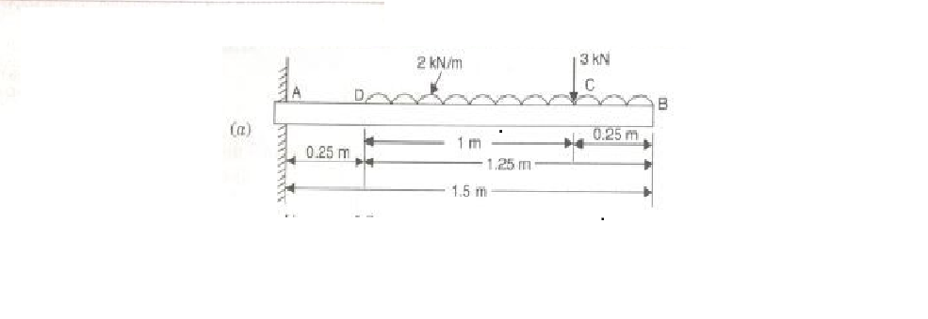

1. A cantilever of length 2.0m carries a uniformly distributed load of 1KN/m run over a length of 1.5m from the free end. Draw the shear force and bending moment diagrams for the cantilever.
2. a. A simply supported beam of length 6m, carries point load of 3 KN and 6KN at distance of 2m and 4m from the left end. Draw the shear force and bending moment diagram for the beam.
3. Draw the shear force and bending moment diagram for a simply supported beam of length 9m and carrying a uniformly distributed load 10KN/m for a distance of 6m from the left end.
4. Draw S.F and B.M diagram for a simply supported beam of length 8m and carrying a uniformly distribution load of 10KN/m for a distance of 4m.
5. A simply supported beam of length 6 m, carries point load of 3 KN and 6 KN at distances of 2 m and 4 m from the left end. Draw the shear force and bending moment diagrams for the beam (**Figure**).

**D**

**B**

**6 m**

**2 m**

**6 KN**

**3 KN**

**C**

**A**

**4 m**

1. A simply supported beam of length 15 m, carries point load of 100kN and 200 kN at distances of11 m and 13 m from the left end. Draw the shear force and bending moment diagrams for the beam.
2. A horizontal beam AB of length 4 m is hinged at A and supported on rollers at B. The Beam carries inclined loads of 100 N, 200 N and 300 N inclined at 60, 45 and 30 degrees to the horizontal as shown in **(Figure).** Draw the shear force, bending moment and thrust diagram for the beam.

**D**

**8 m**

**2 m**

**200 N**

**100 N**

**300 N**

**60°**

**45°**

**30**

**4 m**

**6 m**

**C**

**E**

**HA**

**A**

**B**

1. A simply supported beam of length 5 m carries a uniformly increasing load of 800 N/m run at one end to 1600 N/m at the other end. Draw shear force and bending moment diagrams for the beam. Also calculated the position and magnitude of maximum bending moment.
2. A simply supported beam of length 10 m carries a uniformly increasing load of 1000 N/m run at one end to 2000 N/m at the other end. Draw shear force and bending moment diagrams for the beam. Also calculated the position and magnitude of maximum bending moment.
3. A simply supported beam of length 6 m, carries point load of 5 kN and 10 kN at distances of 2 m and 4 m from the left end and uniform distributed load of 45 kN/m over length of 2 m from the right end. Draw the shear force and bending moment diagrams for the beam **(Figure).**

**D**

**B**

**6 m**

**2 m**

**6 KN**

**3 KN**

w=10 KN/m

**C**

**A**

**4 m**

**UNIT-III-TRANSVERSE LOADING ON BEAMS-II**

**PART-A**

**EACH QUESTION CARRIES 2 MARKS**

1. Define bending stress.
2. Define pure bending.
3. What is mean by deflection of beam?
4. Define positive bending moment?
5. What is Point of inflexion?
6. What do you mean by thrust diagram?
7. Define simple bending.
8. Define Shear section.
9. Define Moment of Inertia.
10. List out different methods to calculate moment of inertia.

**PART-B**

**EACH QUESTION CARRIES 4 MARKS**

1. Discuss about theory of simple bending.
2. Derive for expression for bending stress.
3. Brief about moment of resistance.
4. Discuss about shear variation in beams
5. Discuss about section modulus for the beam
6. Define moment of inertia.
7. Find the centroidal principal moments of inertia of an equal angle section 30 mm x 30 mm x 10 mm.
8. A compound tube is composed of 250 mm internal diameter and 25 mm thick shrunk on tube of 250 mm external diameter and 25 mm thick. The radial pressure at the junction is 8 N/mm
9. Find the variation of hoop stress over the wall of the compound tube.
10. Calculate the thickness of metal necessary for a steel cylindrical shell of internal diameter 100 mm to withstand an internal pressure of 40 N/mm2, if the allowable tensile stress is 120 N/mm2.
11. Explain with figure the conduct of Fatigue test for a material in the laboratory.
12. Find the thickness of metal necessary for a steel cylinder of internal diameter 200 mm to withstand an internal pressure of 50 N/mm2. The maximum hoop stress in the section is not to exceed 150 N/mm2. Assume thick cylinder.
13. 6. An equal angle section 150 mm x 150 mm x 10 mm is used as a simply supported beam of 4 m length is subjected to a vertical load passing through the centroid. Determine bending stress at point A as shown in fig.
14. Find the principal moment of inertia of angle section 60 mm x 40 mm x 6 mm. 8. Find the thickness of metal necessary for a cylindrical shell of internal diameter 150 mm to withstand an internal pressure of 50 N/mm2. The maximum hoop stress in the section is not to exceed 150 N/mm2.
15. Determine the principal moment of inertia for an unequal angle section 60 mm x40 mm x 6mm.

**PART-C**

**EACH QUESTION CARRIES 14 MARKS**

1. Find the principal moment of inertia of channel section shown in fig. 11
2. A beam of Tee section having flange of 100 mm x 20 mm and web of 150 mm x 10mm and 3 m long is simply supported at its ends. It carries 4 kN at 30 ° to vertical and passing through the centroid of the section. Calculate the maximum tensile stresses and maximum compressive stresses. E = 200 kN/mm2.
3. Determine the principal moment of inertia for an angle section 80 mm x80 mm x 10 mm as shown in Figure 12
4. A 80 x 80 x 10 mm angle is used as a simply supported beam over a span of 2.4 m. It carries a load of 400 kN along the vertical axis passing through the centroid of the section. Determine the resulting bending stress on the outer corners of the section along the middle section of the beam.
5. A beam of length 5m and uniform rectangular section is supported at its end and carries uniformly distributed load over the entire length. Calculate the depth of the section if the maximum permissible bending stress is 8 N/mm2 and central deflection is not exceed 10mm.
6. Draw the shear force and bending moment diagram for a simply supported beam of length 9 m and carrying a uniformly distributed load of 10 kN/m for a distance of 6 m from the left end. Also calculate the maximum Bending moment on the section **(Figure (3H).**



1. A simply supported beam of length 4 m, carries point load of 30 kN and 60 kN at distances of 8 m and 12 m from the left end and uniform distributed load of 25 kN/m over length of 4 m from the right end. Draw the shear force and bending moment diagrams for the beam **(Figure)**

**D**

**B**

**12 m**

**4 m**

**60 KN**

**30 KN**

w=25 KN/m

**C**

**A**

**8 m**

1. A horizontal beam AB of length 18 m is hinged at A and supported on rollers at B. The Beam carries inclined loads of 10 N, 20 N and 30 N inclined at 60, 45 and 30 degrees to the horizontal as shown in **Figure.** Draw the shear force, bending moment and thrust diagram for the beam.

**D**

**18 m**

**12 m**

**20 N**

**10 N**

**30 N**

**60°**

**45°**

**30**

**14 m**

**16 m**

**C**

**E**

**HA**

**A**

**B**

**FIGURE**

**FIGURE 11**

10 mm

45 mm

6 mm

40 mm

**FIGURE 12**

10 mm

45 mm

6 mm

40 mm

**FIGURE 13**

20 mm

45 mm

6 mm

40 mm

**UNIT-III-DEFLECTION OF BEAMS**

**PART-A**

**EACH QUESTION CARRIES 2 MARKS**

1. Define the term Maximum deflection of the beam.
2. Under what condition, the slope of a deflected beam is zero?
3. List the different methods for deflection of beam?
4. Under what condition at that point the bending moment will be maximum.
5. What is significance of the Macaulay’s method?
6. Write the steps involved in Macaulay’s method for finding deflection and slope.
7. Under what condition, the slope of a deflected beam is zero?
8. What is the deflection by moment area method?
9. Write unit for bending moment and moment of inertia?
10. Where will be the maximum deflection, if an uniform load acting entire span of simple supported beam.
11. Write the equation for the radius of the curvature of the deflected beam.
12. List out the methods for determining the slope and deflection.

**PART-A**

**EACH QUESTION CARRIES 4 MARKS**

1. Explain about the Macaulay’s method and where it is used?
2. A beam of length 6m is simply supported at its end and carrying two point load of 48KN ata distance of 1m and 3m respectively from the left support. Find the Deflection under each load, Given E= 2x105 N/mm2 , I = 88x106 mm4
3. A beam 6 m long, simply supported at its ends, is carrying a point load of 50 KN at its center. The moment of inertia of the beam (i.e. I) is given as equal to 78 x 106 mm4. If the E for the material of the beam = 2.1 x 105 N/mm2, calculate: (i) deflection at the center of the beam and (ii) slope at the supports.
4. A beam 3 m long, simply supported at its ends, is carrying a point load of 30KN at its center. The moment of inertia of the beam (i.e. I) is given as equal to 36 x 106 mm4. If the E for the material of the beam = 2.1 x 105 N/mm2, calculate: (i) deflection at the center of the beam and (ii) slope at the supports.
5. What is the relation between curvature, slope, deflection and shear force at a section of beam?
6. A beam 4 meter long, simply supported at its ends, and carries a point load W at its center. If the slope at the ends of the beam is not to exceed 1°, find the deflection at the center of the beam.
7. Determine: (i) slope at the left support, and (ii) deflection under the load of a simply supported beam of length of 5 m, which is carrying a point load of 5 kN at a distance of 3m from the left end. Take E=2x105 N/mm2 and I= 1x108 mm4.

**PART-C**

**EACH QUESTION CARRIES 14 MARKS**

1. A beam of length 6 m is simply supported at its ends and carries two point loads of 48 KN and 40 KN at at a distance of 1 m and 3 m respectively from the left support. Find:

(i) Deflection under each load

(ii) Maximum deflection, and

(iii) The point at which maximum deflection occurs.

1. A beam of length 6 m is simply supported at its ends and carries a point load of 40 KN at a distance of 4 m from the left support. Find the deflection under the load and maximum deflection. Also calculate the point at which maximum deflection takes place. Given E=2x105 N/mm2 and I=7.33x108 mm4.
2. A beam of length 2 m is simply supported at its ends and carries a point load of 20 KN at a distance of 1 m from the left support. Find the deflection under the load and maximum deflection. Also calculate the point at which maximum deflection takes place. Given E=2x105 N/mm2 and I=7.33x108 mm4.
3. A beam of length 6 m is simply supported at its ends and carries two point loads of 48 KN and 40 KN at a distance of 1 m and 3 m respectively from the left support. Find: (i)Deflection under each load, (ii) Maximum deflection, and (iii)the point at which maximum deflection occurs.
4. A beam of length 8 m is simply supported at its ends. It carries a uniformly distributed load of 40 kN/m as shown in (Figure (4A). Determine the deflection of the beam at its mid-point and also the position of maximum deflection and maximum deflection. Take E=2x105 N/mm2 and I=4.3x108 mm4.