DEPARTMENT OF PHYSICAL EDUCATION
CHENNAI CORPORATE CRICKET TOURNAMENT
WINNER - 2013- 14
AMET UNIVERSITY STAFF CRICKET TEAM
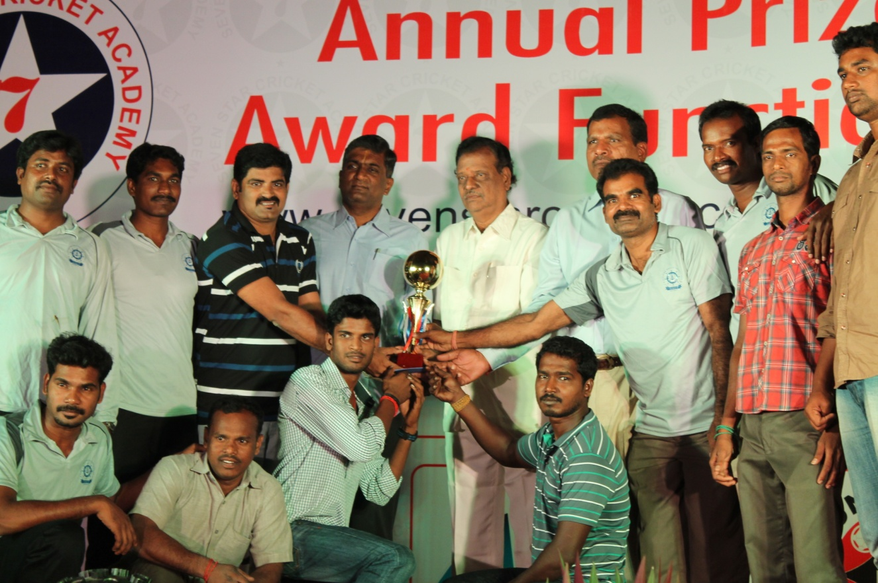
Chennai Corporate Cricket League Tournament was organized by Seven Star Cricket Assn. for the last 4 Years. More than 20 Chennai Corporate teams were participated in this tournament and our University staff teams also participated and secure the Winner 2013-14. The prize distribution function is held at 05th November, 2014 at the Seafarers Club, Chennai.

In this Juncture, we thank the our Management, Honorable Vice Chancellor, Registrar, Faculty, Team members, Transport and the Canteen Department for the enormous support rendered by them towards this Victory.

WINNERS 2013-14
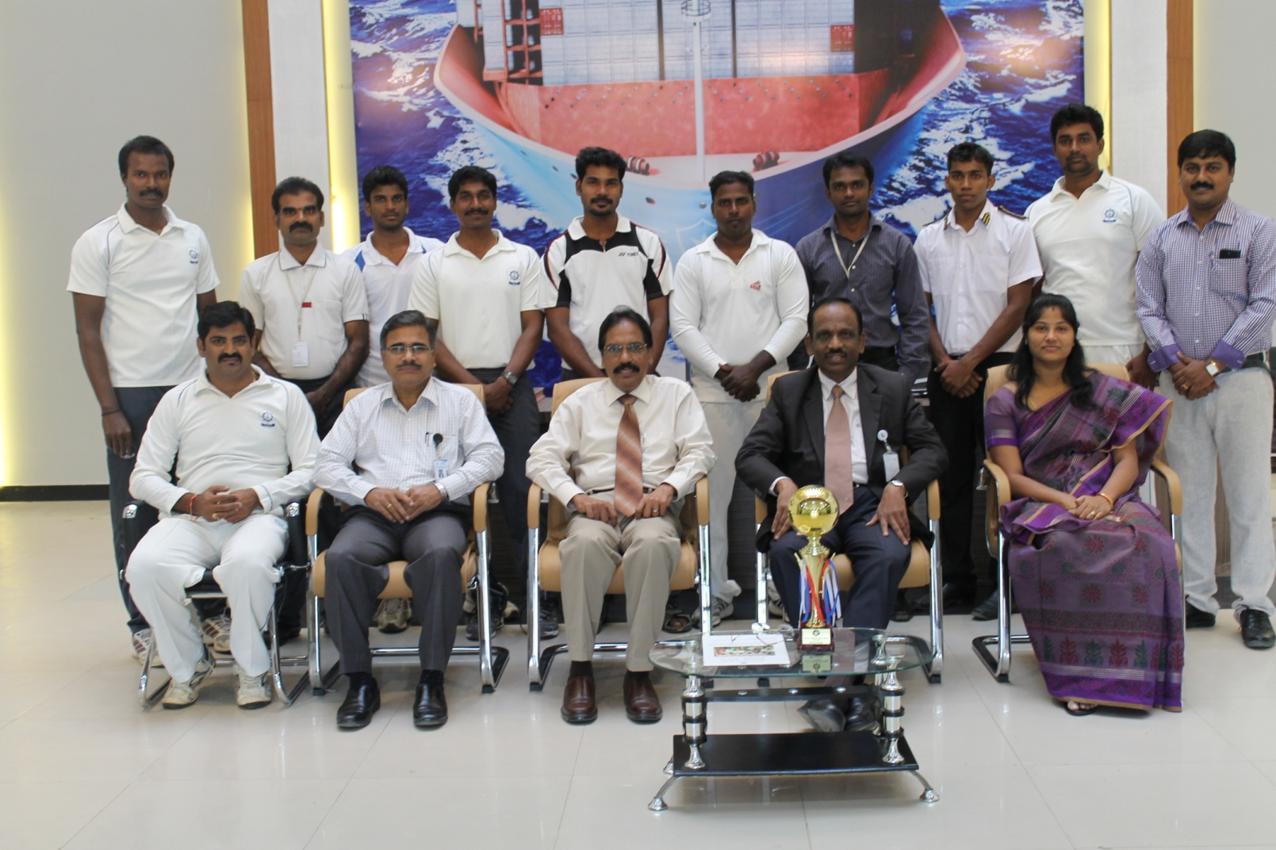
CONGRATULATIONS

